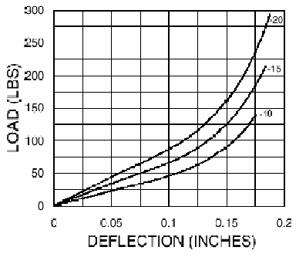

Approximate Slope = 50/0.05 = 1000 lb/in
*** 1 lb/in = 175.126835

K = 175.126835 kN/m

